

MS Word Training- Session-3.1: Part-1

Table of Contents (TOC)
Version: 1.0
February 2009
Copyright Information:
This document is the sole property of AIG Inc. All rights reserved. No part of this document may be reproduced, stored in a retrieval system, translated, transcribed, or transmitted in any form or by any means, without the prior written permission of AIG Systems Solutions (AIGSS).
Document Information
S.No | Document Title | Base Version No. | Author | Contact Email ID | Date Of Release
1 | Tables of contents (TOC) | 1.0 | Deepika Datta | deepika.datta@aig.com | February 2009
Revision History
S.No | Version No. | Date Of Release | Author (s) | Affected Section(s) | History of Changes | Approver

Table of Contents
1 Tables of contents 4
1.1 Introduction 4
1.2 To generate a TOC 4
1.3 Update a TOC 4
2 Table of Figures 6
2.1 Creating Table of Figures 6
2.1.1 To mark text as a caption: 6
2.1.2 To generate a Table of figures 7
3 Formatting Table of contents/ Table of Figures 8
4 Trouble shooting – Table of contents 9
4.1 My table of contents contains text other than my headings. 9
4.2 The table of contents isn't formatted correctly. 9

Tables of contents

Introduction
A table of contents, or TOC, gives readers a brief outline of the topics discussed in a document and helps them find their way around it.
A table of contents is a reader's map. It provides an overview of what is in the document and helps readers find a particular section quickly.
A TOC may be a simple list of chapter titles, or it can include several heading or outline levels.
An instruction manual that will be printed may need several levels of headings and subheadings in the TOC along with their corresponding page numbers. On the other hand, an inspection report that will be viewed on screen might just need links to the main sections from the TOC. Either way, it's easy to do.

To generate a TOC
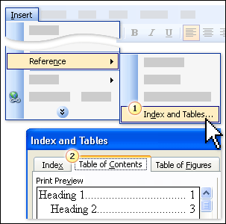
- Mark Text that has to appear in the TOC by applying heading styles.
- Place the cursor where the TOC has to appear.
- On the Insert menu, point to Reference, then click Index and Tables.
- Click the Table of Contents tab. If you want a TOC in the default style, just click OK.

Update a TOC
Once you've built your TOC, you'll probably have to maintain it. If you include more headings in your document, or simply add more content, you'll want the TOC to include the new headings and show the right page numbers.
Right click on the TOC and Select Update Field
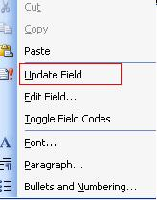
When you update a TOC, you will be asked to choose whether to update the entire table or just page numbers.
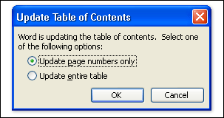
- Choose the page numbers option only if you've been adding body text but no new headings— it's faster and will save you time in a long document
- But if you've added a new heading or changed any text included in the TOC, choose the Update entire table option.
Avoid editing entries in the TOC itself— if you ever update the TOC you'll lose those changes.
To change text that appears in the TOC, be sure to edit this text in the body of the document— not in the TOC, and then press F9 to compile the changes.
Tip :Always update a TOC as the last thing you do to a document before printing or sending it out; that way you'll always include any last minute changes.

Table of Figures
Many professional documents have other types of reference tables in addition to a TOC; for example, scientific papers or papers submitted at school have tables of figures. Once you know how TOCs work, you'll find that creating other tables of reference is a similar process
A table of figures shows the page number of each figure in your document.
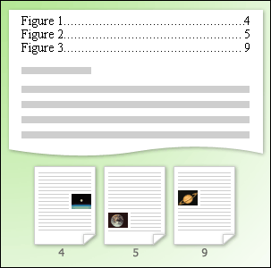

Creating Table of Figures

To Label the figures
- On the Insert menu, point to Reference…and then click Caption.
- Enter your requirements in the Caption dialog box; then click OK.
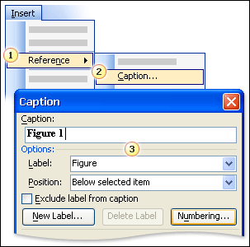
You won't be surprised to hear that a table of figures works in the same way as a TOC. This time the text entries are captions, which are then collected into the table of figures.
Behind the scenes, a table of figures is, in fact, a TOC

To generate a Table of figures
- Place the cursor where the Table of Figures has to appear.
- On the Insert menu, point to Reference, then click Index and Tables.
- Click the Table of Figures tab. If you want a Table of Figures in the default style, just click OK.
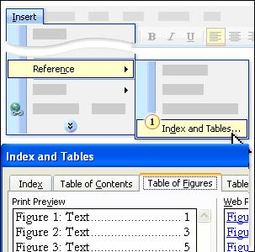

Formatting Table of contents/ Table of Figures
Now that you know how to create a table of contents, jazz it up a bit by formatting the entire TOC to make the entries clearer, more attractive, and easier to read.
There are several built–in TOC formats available in Word. And there are other formatting options available to you as well, such as using those dots that appear between the TOC entry and the corresponding page number, and having hyperlinks in the TOC of an on–screen document.
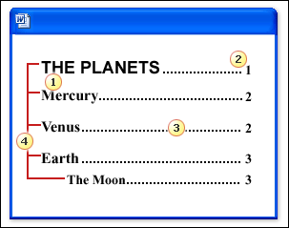
Elements of a TOC that can be altered:
- The font details, such as size, type, and color.
- Position of page numbers.
- Type of tab leaders.
- Number of levels. There are three levels here: "The Planets" is at the first level; "Mercury," "Venus," and "Earth" are at the second; and "The Moon" is at the third.
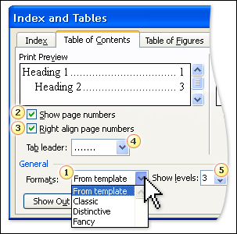
- Change the format of your TOC.
- Show or hide page numbers.
- Align page numbers.
- Choose a tab leader.
- Choose the number of levels required.
The From template option is a format that refers to an existing TOC style in the document you're working in. This means that instead of applying a new format, you could make changes to the existing TOC's format; so if you had chosen the Classic format you could then go back and make amendments to it. (If there is no existing TOC style in the document you're working in, then it will be a plain TOC with only the formatting you choose to apply in the dialog box.)
After redesigning an existing TOC in the dialog box, you'll be asked if you want to replace the old one. Just click OK: You'll replace the old TOC with the one including your new format.

Change the appearance of a table of contents
- On the Insert menu, point to Reference, click Index and Tables, and then click the tab you want.
- In the Formats box, click From template, and then click Modify.
- In the Styles box, click the style you want to change, and then click Modify.
- To add the new style definition to your template, select the Add to template check box.
- Under Formatting, select the options you want.
Notes
- To change the appearance of a table of contents in a Web frame, you must first position the insertion point inside the frame that contains the table of contents.
- To change the appearance of a table of contents in a Web frame that uses hyperlinks, change the properties of the hyperlink style.
- To edit the text of an individual entry, locate the source of the entry, modify it, and then update the entire table of contents or Table of figures.

Trouble shooting – Table of contents

My table of contents contains text other than my headings.
Try one of the following:
Apply a different heading style to specific headings
Microsoft Word includes in the table of contents all text and graphics formatted with the following styles:
- built-in heading styles
- styles that include outline-level
- custom styles you specified.
If unwanted text and graphics appear in your table of contents, apply a style other than one of these heading styles to the unwanted text or graphics.
Omit headings formatted with specific heading styles
You can also omit a heading (for example, a book title) from the table of contents without changing its heading style.
- On the Insert menu, point to Reference, click Index and Tables, and then click the Table of Contents tab
- Click Options, and then delete the number for the appropriate style in the TOC level box.
Note that all text formatted with this heading style will be omitted from the table of contents.

The table of contents isn't formatted correctly.
- When you choose a design and build a table of contents, Microsoft Word automatically uses the TOC styles (for example, TOC 1 and TOC 2) to format the headings in the finished table of contents.
- If you want to change the formatting in the table of contents, choose a different design when you build the table of contents.
- If you want to match the formatting of the headings in the table of contents with that of the headings in the document, you can modify the TOC styles.
- If you manually format a heading in your document (for example, make it bold), this formatting is reflected in the finished table of contents.

